In OFFICE.COM (for instructions for Outlook for the Desktop go to the next page)

Allowing Others to View Your Calendar

Click on your Calendar View from the options at the bottom left of your screen



In the top right corner click on Share


Set PEOPLE IN MY ORGANIZATION to: Can view all details

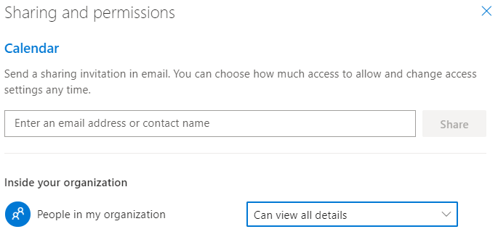

Click the X to close the window.
In Outlook for the Desktop

Go to Calendar

Go to Calendar Permissions in the Ribbon

Select Default

Select Full Details under READ

Select YES

Select OK

